Authentication Services

🔐 What Is the Authentication Services Component in a Mail Server System?
# Source: AI Source: Provided by: [Data Path: Persons Table -> ID Column: 1, Name_En Column: Motasem Essam] -> From: [ChatGPT] on [1/21/2026]
The Authentication Services Component is responsible for verifying the identity of users who try to send or access email through the mail server.
It ensures that only authorized users can:
- Log in to check their inbox (via IMAP/POP3 or Webmail),
- Send emails through the SMTP server,
- Access the mail system through mobile or desktop clients.

🧠 Why It's Essential
# Source: AI Source: Provided by: [Data Path: Persons Table -> ID Column: 1, Name_En Column: Motasem Essam] -> From: [ChatGPT] on [1/21/2026]
Without authentication:
- Anyone could use your mail server to send spam (open relay).
- Users could read others’ emails.
- Your server could be blacklisted or compromised.

🔑 When Authentication Happens
# Source: AI Source: Provided by: [Data Path: Persons Table -> ID Column: 1, Name_En Column: Motasem Essam] -> From: [ChatGPT] on [1/21/2026]
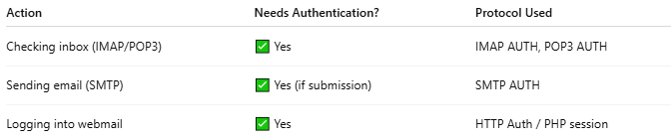

Action | Needs Authentication? | Protocol Used
Checking inbox (IMAP/POP3) | ✅ Yes | IMAP AUTH, POP3 AUTH
Sending email (SMTP) | ✅ Yes (if submission) | SMTP AUTH
Logging into webmail | ✅ Yes | HTTP Auth / PHP session

⚙️ Common Authentication Methods
# Source: AI Source: Provided by: [Data Path: Persons Table -> ID Column: 1, Name_En Column: Motasem Essam] -> From: [ChatGPT] on [1/21/2026]
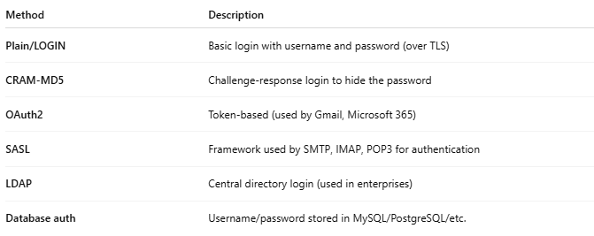

Method | Description
Plain/LOGIN | Basic login with username and password (over TLS)
CRAM-MD5 | Challenge-response login to hide the password
OAuth2 | Token-based (used by Gmail, Microsoft 365)
SASL | Framework used by SMTP, IMAP, POP3 for authentication
LDAP | Central directory login (used in enterprises)
Database auth | Username/password stored in MySQL/PostgreSQL/etc.

🔁 Where It Fits in the Mail Server System
# Source: AI Source: Provided by: [Data Path: Persons Table -> ID Column: 1, Name_En Column: Motasem Essam] -> From: [ChatGPT] on [1/21/2026]
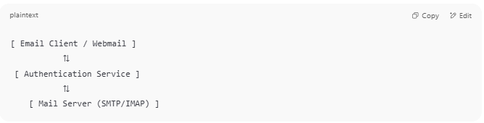
[ Email Client / Webmail ]
⇅
[ Authentication Service ]
⇅
[ Mail Server (SMTP/IMAP) ]

- When a user tries to send or receive mail, the system checks their credentials first.
- Only after successful authentication can the mail operation proceed.

🧰 Tools That Handle Authentication
# Source: AI Source: Provided by: [Data Path: Persons Table -> ID Column: 1, Name_En Column: Motasem Essam] -> From: [ChatGPT] on [1/21/2026]
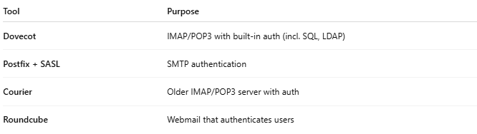

Tool | Purpose
Dovecot | IMAP/POP3 with built-in auth (incl. SQL, LDAP)
Postfix + SASL | SMTP authentication
Courier | Older IMAP/POP3 server with auth
Roundcube | Webmail that authenticates users

✅ Summary
# Source: AI Source: Provided by: [Data Path: Persons Table -> ID Column: 1, Name_En Column: Motasem Essam] -> From: [ChatGPT] on [1/21/2026]
The Authentication Services Component ensures that only authorized users can send or receive mail, helping to keep your mail server secure, private, and abuse-free.

